BASAVARAJESWARI GROUP OF INSTITUTIONS

BALLARI INSTITUTE OF TECHNOLOGY & MANAGEMENT
NBA and NACC Accredited Institution


(Recognized by Govt. of Karnataka, approved by AICTE, New Delhi & Affiliated to Visvesvaraya Technological University, Belagavi) "Jnana Gangotri" Campus, No.873/2,
Ballari-Hosapete Road, Allipur, Ballari-583 104 (Karnataka) (India) Ph:08392 237100 / 237190, Fax: 08392 –
Department of Artificial Intelligence and Machine Learning
A Mini Project Report On

“AI and Deep Learning-Based Hand Gesture Dino Game”
A report submitted in partial fulfillment of the requirements for the Mini project of Neural Networks and Deep Learning (22AIL71)
Submitted By

Name | USN
Anjali | 3BR22AI009
B Aishwarya | 3BR22AI018
Bhavana Joshi | 3BR22AI025
G Sahethi | 3BR22AI045

Under the Guidance of
Mrs. Chandrakala (Asst. Professor)

Mr. Zaheed Hussain (Teaching Assistant)

BASAVARAJESWARI GROUP OF INSTITUTIONS

BALLARI INSTITUTE OF TECHNOLOGY & MANAGEMENT
NBA and NACC Accredited Institution
(Recognized by Govt. of Karnataka, approved by AICTE, New Delhi & Affiliated to Visvesvaraya Technological University, Belagavi) "Jnana Gangotri" Campus, No.873/2,
Ballari-Hosapete Road, Allipur, Ballari-583 104 (Karnataka) (India) Ph:08392 237100 / 237190, Fax: 08392 –

Department of Artificial Intelligence and Machine Learning

CERTIFICATE

Certified that the mini project work entitled “AI and Deep Learning-Based Hand Gesture Dino Game” carried out by Anjali, B Aishwarya, Bhavana Joshi, G Sahethi bearing 3BR22AI009, 3BR22AI018, 3BR22AI025, 3BR22AI045 Bonafide students of Ballari Institute of Technology and Management, of Artificial Intelligence and Machine Learning Department during the year 2025- 2026, Have submitted the following report for the partial fulfillment of the requirements for Neural Networks and Deep Learning Laboratory. The work reported here is original and is carried out under our supervision.

Signature of Guide | Signature of Guide | Signature of HOD
Mrs. Chandrakala | Mr. Zaheed Hussain | Dr. B M Vidyavathi

ABSTRACT

This project presents an AI and Deep Learning-based Hand Gesture Controlled Dino Game that enables users to interact with a virtual environment using intuitive hand movements instead of traditional input devices. The system leverages MediaPipe’s pre-trained deep neural networks to detect and track 21 hand landmarks in real time through a webcam feed. These landmarks are processed using computer vision techniques in OpenCV to recognize gestures such as a closed fist or open palm. The gesture information is then used to control the Dino character in a Pygame-based interface, allowing actions like jumping or running to be performed without any physical contact. This integration of deep learning, gesture recognition, and human-computer interaction demonstrates how artificial intelligence can be applied to create immersive and touchless gaming experiences. The project highlights the potential of combining convolutional neural networks (CNNs) with real-time vision systems for interactive entertainment, virtual control systems, and accessibility applications.

TABLE OF CONTENTS

Sl No. | Content | Page No
1 | Introduction | 1
2 | Literature Survey | 2
3 | Problem Statement | 3
4 | Software & Hardware Requirements | 4
5 | About The Project | 5
6 | System Design & Implementation | 6
7 | Snapshots | 7
8 | Conclusion | 8
9 | Bibliography | 9

INTRODUCTION

With the rapid advancement of artificial intelligence (AI) and deep learning, human–computer interaction has evolved from traditional keyboard and mouse input to more natural and intuitive forms of communication. One such approach is gesture-based control, where physical hand movements are interpreted by intelligent systems to perform digital actions. This concept forms the foundation of the AI and Deep Learning-Based Hand Gesture Controlled Dino Game, which combines computer vision, neural network-based hand tracking, and interactive gameplay to create a touchless and immersive gaming experience.
In this project, MediaPipe’s pre-trained deep neural network model is employed to detect and track 21 three-dimensional hand landmarks in real time through a webcam feed. These landmark coordinates are analyzed using OpenCV to interpret hand gestures such as open palms or closed fists. The recognized gestures are then mapped to corresponding in-game actions within a Pygame interface — for example, a closed fist triggers the Dino character to jump. This seamless integration between AI-powered vision processing and interactive graphics enables users to control the game using simple hand movements without any physical contact.
The system demonstrates the practical application of convolutional neural networks (CNNs) for gesture recognition and real-time motion tracking, emphasizing how deep learning can enhance user engagement in digital environments. Beyond gaming, the underlying framework has potential applications in virtual reality interfaces, robotic control, and assistive technologies, showcasing the versatility of AI-based gesture recognition in modern human–computer interaction systems.

1

LITERATURE SURVEY
 | AUTHOR AND TITLE | YEAR | SUMMARY OF APPROACH
 | K. Sahoo and P. Singh — “Vision-Based Human Computer Interaction Using Hand Gestures” (IEEE ICCCIS) | 2021 | Proposed a computer vision pipeline using OpenCV and CNNs for gesture-based system control. Focused on enhancing real-time performance and accuracy in dynamic lighting conditions.
 | R. Singh and N. Kaur — “Gesture Controlled Gaming Using Computer Vision” (IJCA) | 2022 | Demonstrated gesture-based control in simple games using webcam input. Implemented OpenCV and Python to recognize hand gestures mapped to in-game actions like jump and move, showing potential for touchless gaming.
 | Biswas, S. et al. — “Real-Time Hand Gesture Recognition Using MediaPipe and LSTM Networks” (IJRASET) | 2023 | Combined MediaPipe landmark detection with LSTM for recognizing dynamic gestures from continuous frames. Improved gesture classification accuracy and temporal understanding for interactive systems.
2

PROBLEM STATEMENT
To develop an AI and Deep Learning-based Hand Gesture Controlled Dino Game that enables users to play using real-time hand movements instead of traditional input devices. The system utilizes Convolutional Neural Networks (CNNs), MediaPipe, and computer vision techniques to detect and interpret hand gestures from webcam input, allowing touchless and intuitive gameplay while enhancing user interaction and accessibility.

3

Proposed System
The proposed system enables real-time control of the Dino game through AI-based hand gesture recognition using deep learning and computer vision techniques. It eliminates the need for physical input devices by interpreting hand movements captured through a webcam.
- Hand Detection and Tracking using MediaPipe’s pre-trained CNN model to identify and map 21 hand landmarks in real time.
- Gesture Recognition Module analyzes landmark coordinates using OpenCV and CNN-based feature extraction to classify gestures (e.g., open palm, closed fist).
- Action Mapping Layer converts recognized gestures into specific in-game actions such as jump or run within the Pygame environment.
- Real-Time Processing ensures low-latency response for smooth and accurate gameplay interaction.
- User Interface and Feedback System provides visual feedback, making the game more interactive and engaging.
The system supports adjustable parameters such as gesture sensitivity, detection threshold, and response speed, ensuring accurate performance across varying lighting and hand conditions.

4

Limitations
- The system’s accuracy depends on lighting conditions — poor illumination or shadows can affect gesture detection.
- Background clutter or presence of multiple hands in the frame may lead to incorrect gesture recognition.
- Limited gesture set (e.g., open palm, closed fist) restricts the range of possible in-game controls.
- Requires a webcam with sufficient frame rate and resolution for smooth real-time processing.
- High CPU/GPU usage may occur on low-end systems due to continuous video frame processing.
- The system may not perform well in dynamic backgrounds or when the user moves too far from the camera.
- Noisy or occluded hand movements can reduce recognition accuracy.

5

SOFTWARE AND HARDWARE REQUIMENTS

Hardware Requirements:
• Processor: Intel i5 or above / AMD equivalent
• RAM: Minimum 8 GB (recommended 16 GB for smooth performance)
• Storage: At least 512 MB free space for code, libraries, and dataset files
• Webcam: HD webcam (720p or higher) for real-time hand tracking
• Graphics Support: Basic GPU (optional, for faster CNN processing)
• Input/Output Devices: Monitor, Keyboard (for debugging), Mouse

Software Requirements:

- Operating System: Windows 10 / 11, Linux, or macOS
- Programming Language: Python 3.8 or above
- Libraries and Frameworks:
- OpenCV – for image processing and frame handling
- MediaPipe – for hand landmark detection using CNN models
- NumPy – for numerical computations
- Pygame – for game development and interface design
- TensorFlow / Keras (optional) – for CNN-based model operations
- IDE / Editor: Visual Studio Code / PyCharm / Jupyter Notebook

6

ABOUT THE PROJECT

Features:

• Real-Time Hand Gesture Control: Uses MediaPipe’s CNN-based hand tracking to control the Dino through webcam input.
• Touchless Interaction: Eliminates the need for keyboard or mouse input, enabling a more intuitive and hygienic gaming experience.
• Accurate Gesture Recognition: Detects and differentiates between open and closed hand gestures with high precision.
• Smooth Gameplay Interface: Built using Pygame for a visually engaging and responsive game environment.
• AI-Powered Tracking: Employs deep learning models for robust detection and tracking of 21 hand landmarks.
• Dynamic Scoring System: Increases game speed and difficulty as the player’s score improves.
• Cross-Platform Compatibility: Works on multiple operating systems (Windows, Linux, macOS).
• Lightweight and Efficient: Optimized for real-time performance even on standard hardware setups.

Applications:
- Interactive Gaming: Provides an immersive, gesture-controlled experience for casual and educational games.
- Human–Computer Interaction (HCI): Demonstrates how AI and deep learning can enhance touchless control systems.
- Virtual Reality (VR) and Augmented Reality (AR): Can be adapted for gesture-based controls in immersive environments.
- Accessibility Solutions: Helps users with physical disabilities interact with computers or games through hand gestures.
- Educational Demonstration: Serves as a learning model for understanding CNNs, computer vision, and AI integration.
- AI Research and Development: Offers a foundation for building more advanced gesture recognition or vision-based systems.

SYSTEM DESING AND IMPLEMENTATION
7

System Architecture (High-level):

Input Module: Captures real-time video frames from a webcam as input for gesture recognition. Uses OpenCV to process frames and MediaPipe’s pre-trained Convolutional Neural Network (CNN) models to detect and track 21 hand landmarks.

Gesture Detection Module: Analyzes the hand landmarks to identify specific gestures such as an open palm or closed fist. This is achieved by comparing the relative positions of finger tips and joints, enabling accurate gesture-based classification.

Game Control Module: Maps recognized gestures to corresponding game actions — for example, a closed fist triggers a jump action, while an open hand maintains running. This module bridges the AI recognition layer and the Pygame interface.

Game Environment Module: Implements the Pygame engine to create and manage the Dino game environment, including animations, obstacles, score tracking, and collision detection. It also handles transitions between different game states like Menu, Playing, and Game Over.

Display and Feedback Module: Displays both the game window and the real-time camera feed with visual feedback such as detected hand landmarks, gesture status, and current game score. Ensures smooth synchronization between gesture detection and gameplay response.

Performance Optimization Module: Handles frame rate synchronization and ensures smooth gesture-to-action translation. Manages computational resources to maintain real-time performance even on standard hardware

Modules:

- Input Module: Captures live video from the webcam and prepares frames for gesture detection. Handles camera initialization, frame flipping, and RGB conversion for compatibility with MediaPipe’s CNN model.
- Gesture Detection Module: Utilizes MediaPipe Hands, which employs deep learning-based CNNs for real-time hand landmark detection and gesture classification. Counts the number of fingers shown and interprets them as commands.
- Game Control Module: Maps the recognized gesture output to control commands in the game logic, such as jump or idle. Ensures seamless interaction between the AI detection system and the game’s movement mechanics.
- Game Environment Module: Creates the visual and interactive aspects of the Dino Game using Pygame. Handles animations, obstacle generation, background rendering, score updates, and difficulty progression.
- Display and Feedback Module: Shows both the camera window (gesture recognition feedback) and the game window simultaneously. Displays text overlays such as “Jumping,” “Score,” and detected “Finger Count.

9


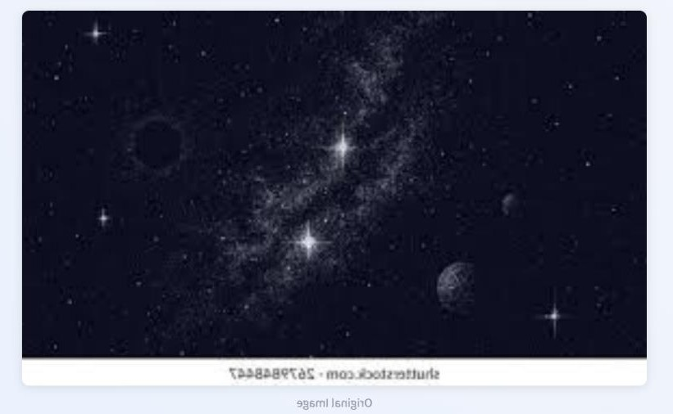
SNAPSHOTS

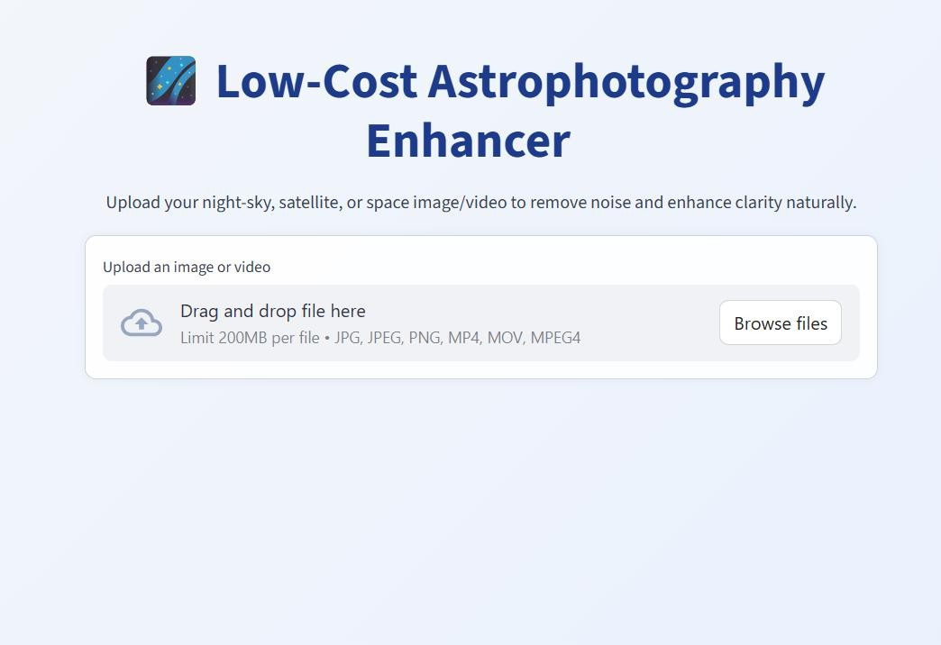
F

10

Conclusion

The Deep Learning and AI-Based Hand Gesture Dino Game successfully demonstrates how artificial intelligence and computer vision can revolutionize human–computer interaction through touchless control systems. By integrating MediaPipe’s CNN-based hand tracking, OpenCV, and Pygame, the system enables users to control a virtual Dino character using simple hand gestures detected in real time. This approach eliminates the need for traditional input devices like keyboards or mice, offering an intuitive, engaging, and hygienic gaming experience.
The project highlights the potential of Convolutional Neural Networks (CNNs) in accurately recognizing and tracking hand gestures, thereby bridging the gap between deep learning and interactive entertainment. Moreover, the system’s modular design ensures scalability, allowing future extensions into virtual reality (VR), augmented reality (AR), and assistive technologies for accessibility. Overall, this work represents an effective fusion of AI, deep learning, and computer vision to create an innovative, real-time, and immersive gaming solution.

11

References
- P. P. Sahu and R. Sharma, “AI-Based Hand Gesture Recognition for Human-Computer Interaction,” International Journal of Advanced Research in Computer Science, vol. 12, no. 3, pp. 45–52, 2021.
- F. Zhang, V. Bazarevsky, and G. Fan, “MediaPipe Hands: On-Device Real-Time Hand Tracking with Machine Learning,” Google Research Publication, 2020.
- Z. Zhang, A. Kanazawa, and J. Malik, “Learning Hand Gesture Recognition Using Convolutional Neural Networks,” IEEE Conference on Computer Vision and Pattern Recognition (CVPR), 2019.
- E. Coumans, “Pygame: A Framework for Real-Time Game Development in Python,” Python Software Foundation, 2020.

12

